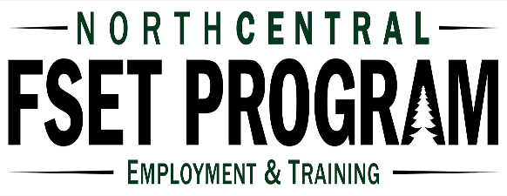

Date: 07-2021
First Name: Jon
Jon re-enrolled in the FSET program on July 20, 2021. Jon had been enrolled in FSET a couple of times in the past but had been dis-enrolled following completion of job retention periods due to being over income after gaining full-time seasonal jobs. Jon’s goal this time was to gain full- time employment that was year-round.

Jon had in the past applied for employment at Walmart but had not been hired. Prior to re-enrolling in FSET Jon had connected with Walmart Human Resource personnel and asked to have a meeting with them to help with completion of the on-line application as this is what had challenged Jon in the past. This was added as an action step to Jon’s enrollment employment plan.

At enrollment FSET inquired and offered support services including interview clothes and hair cut vouchers. Jon stated as had recently been enrolled in FSET that he still had appropriate interview clothes and was not in need of a haircut voucher. At enrollment, again as he had been recently enrolled in FSET, Jon stated he had a current resume and references and was ready to do job search.

On July 30th, Jon reported that he had been offered full-time employment at Walmart as a Stocker with a start date of 08/03/2021 working 40 hours a week at $14.00 per hour. Jon was offered and accepted Job Retention Services including assistance with transportation costs as well as Job Retention Discussion Sessions.

After Jon had worked at his Stocking position at Walmart for almost a month, FSET completed the Maintaining Employment Job Retention Session with Jon discussing potential challenges including bad winter weather, illness, and unanticipated issues. Jon came up with a plan to make sure that he can get to work for his work shifts and if not able to, has a plan of who he needs to communicate with at Walmart to advise if going to miss work due to unanticipated issues. At this appointment, Jon stated was a little concerned about his vehicle and would like to purchase a vehicle that would be more reliable. FSET provided Jon with the contact information for the WETAP program.

Jon will continue to be supported by FSET through his Job Retention period which ends on November 1,2021. Congratulations Jon!

